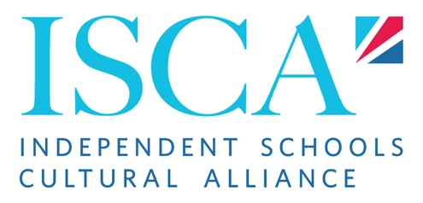

ISCA 2025 Team Application Form

Personal Details
Name:
Email:
Telephone:
Address:

Education:

Work Experience:

Extra-Curricular Activities:

Other Qualifications (e.g. First Aid Course, DBS check etc.):

References – please give at least two references who can be contacted
Name:
Email:
Telephone:
Address:

Name:
Email:
Telephone:
Address:

Why do you want to join the ISCA Programme?
What key skills and experiences make you suitable for this job?
How would your friends describe you?
You are leading a group around Winchester and up to the castle. When you arrive, you learn that the castle you were planning to take the group to is closed. What do you do?
You overhear a student saying something derogatory about another student in your boarding house. How do you address the situation?
Who is your favourite British person in history and why?

Please email this completed form to luke.liddle@iscaschools.com by 31 March 2025

